PYTHON

DEEP LEARNING

ICP – 4

Authored By

Nikhitha Kolluri – 12

**Lesson Overview:**

In this lesson, we are going to discuss Imageclassification with CNN.

**Use Case Description:**

ImageClassification with CNN

1. Training the model

2. Evaluating the model

**Programming elements:**

1. About CNN

2. Hyperparameters of CNN

3. Imageclassification with CNN

**In class programming:**

1. Follow the instruction below and then report how the performance changed.(apply all at once)

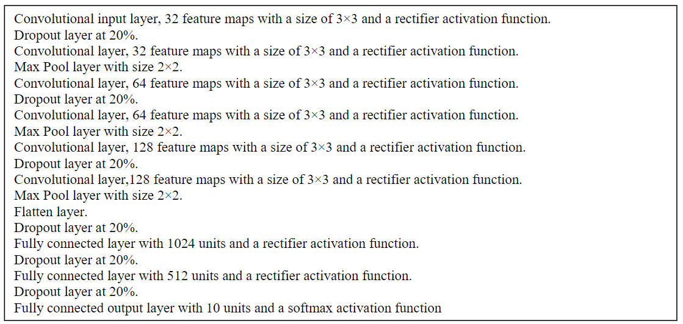

Did the performance change?

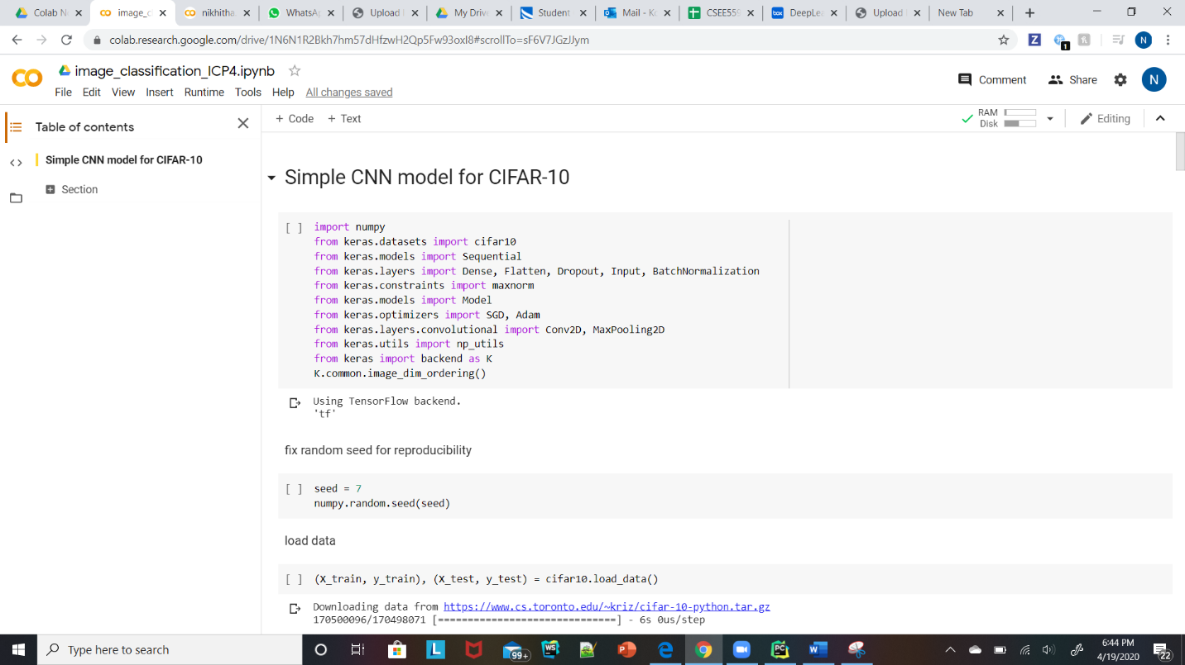

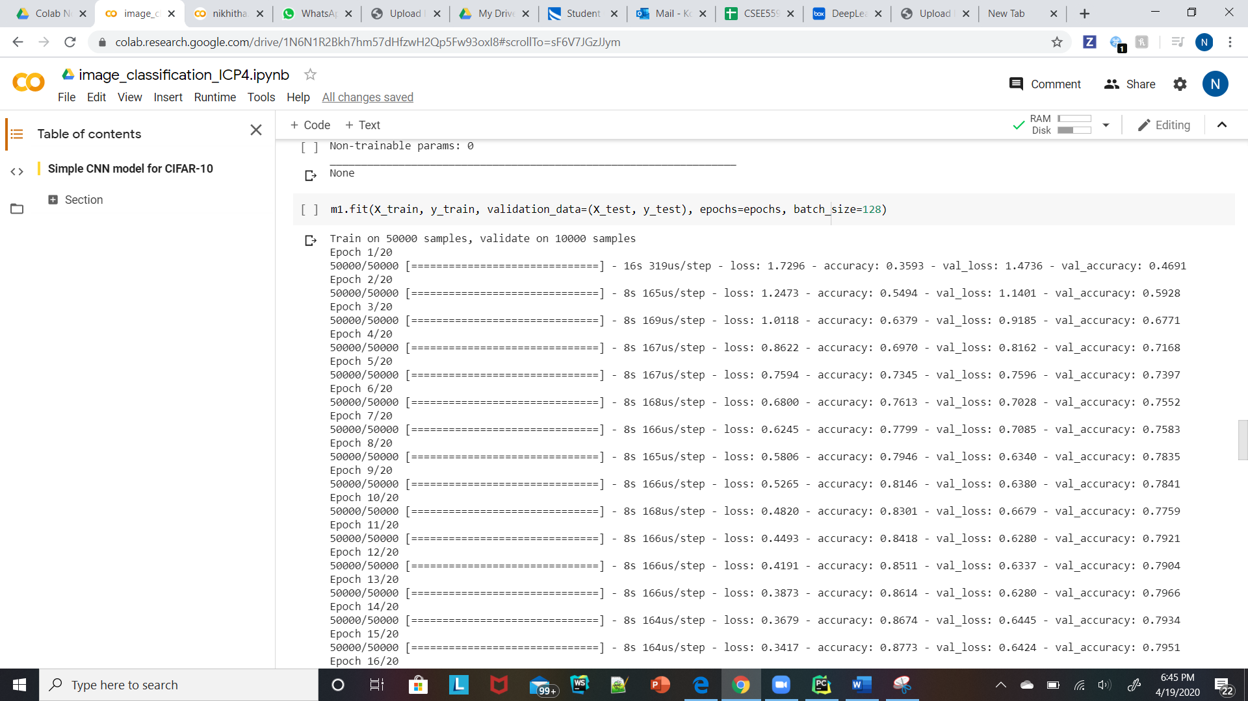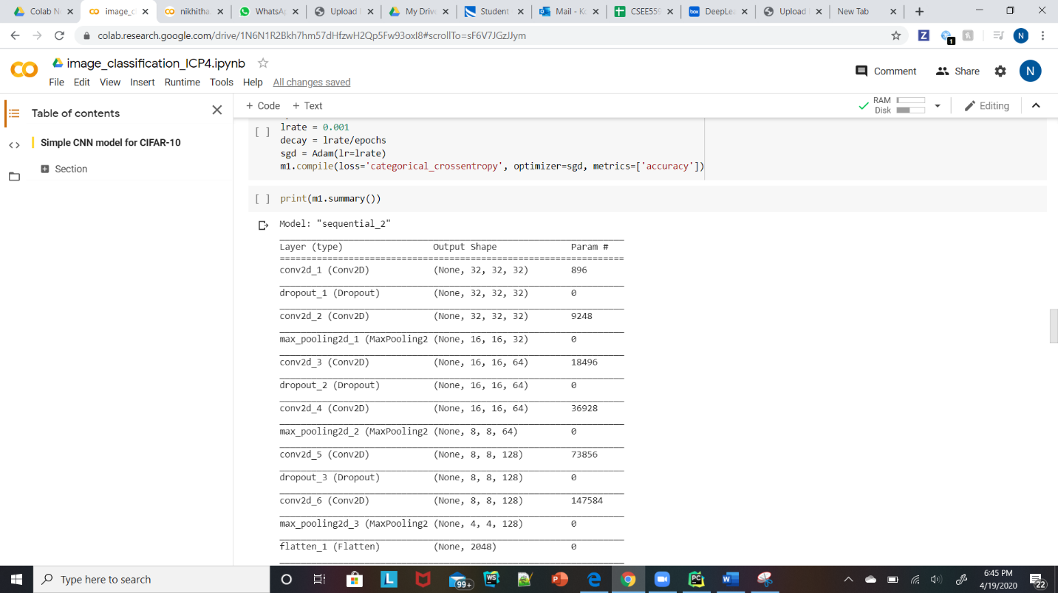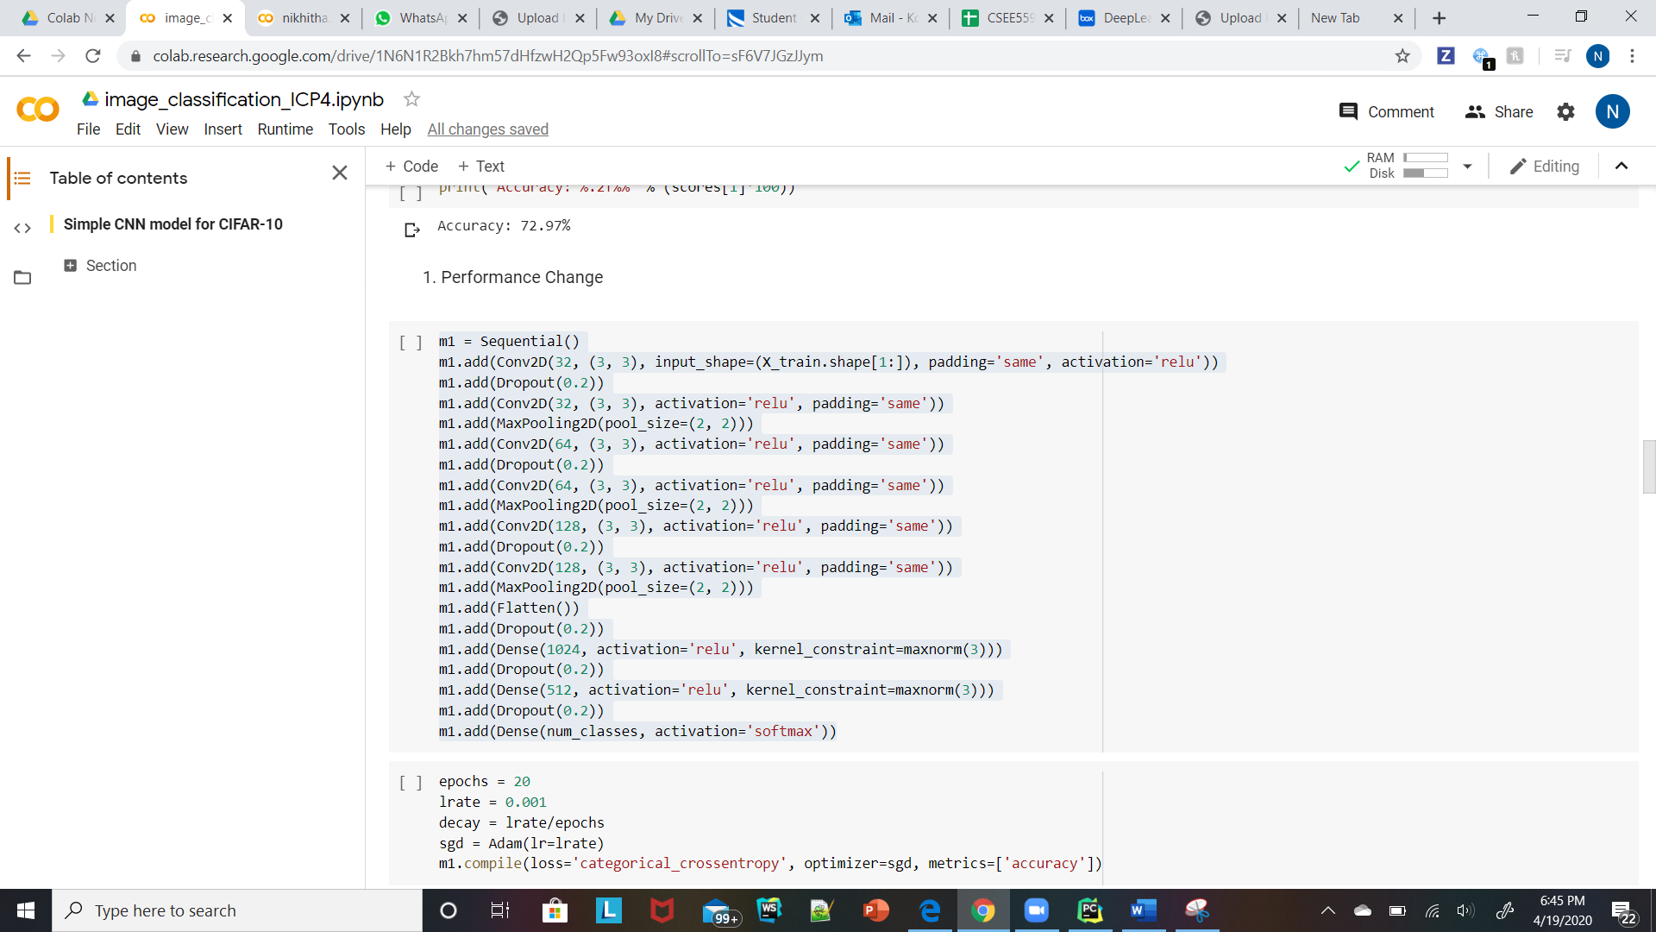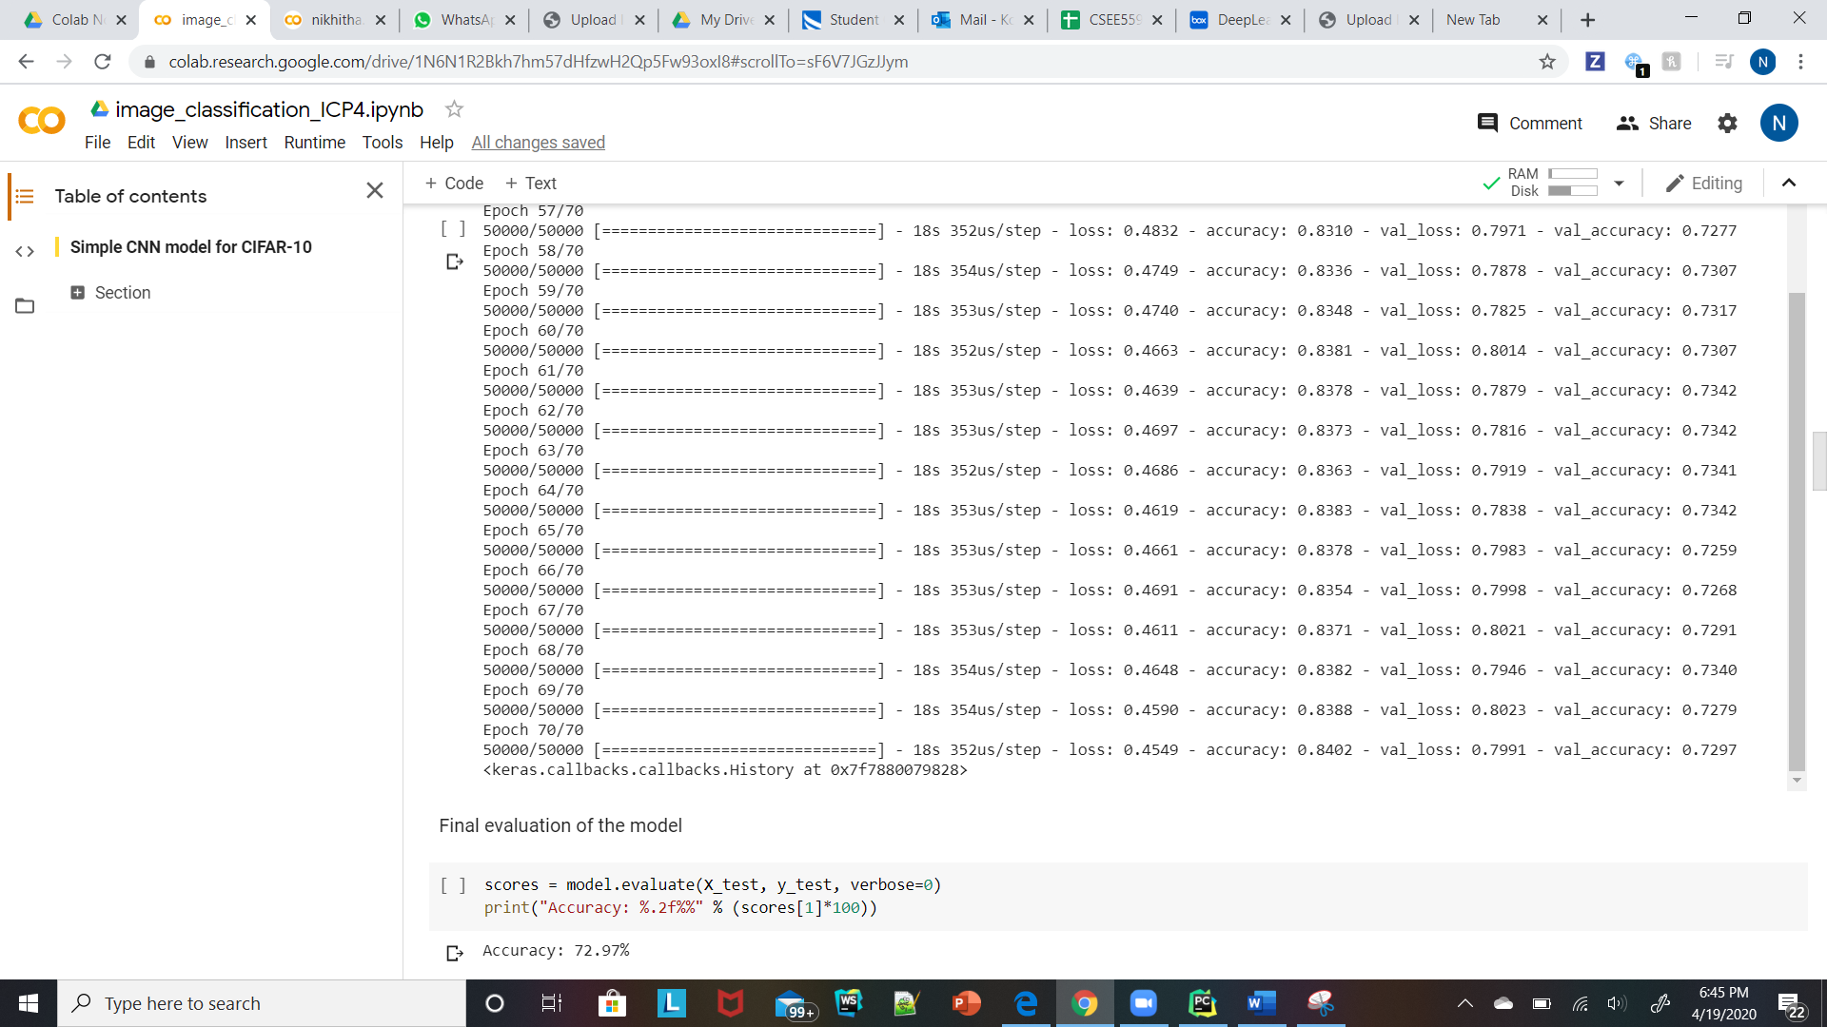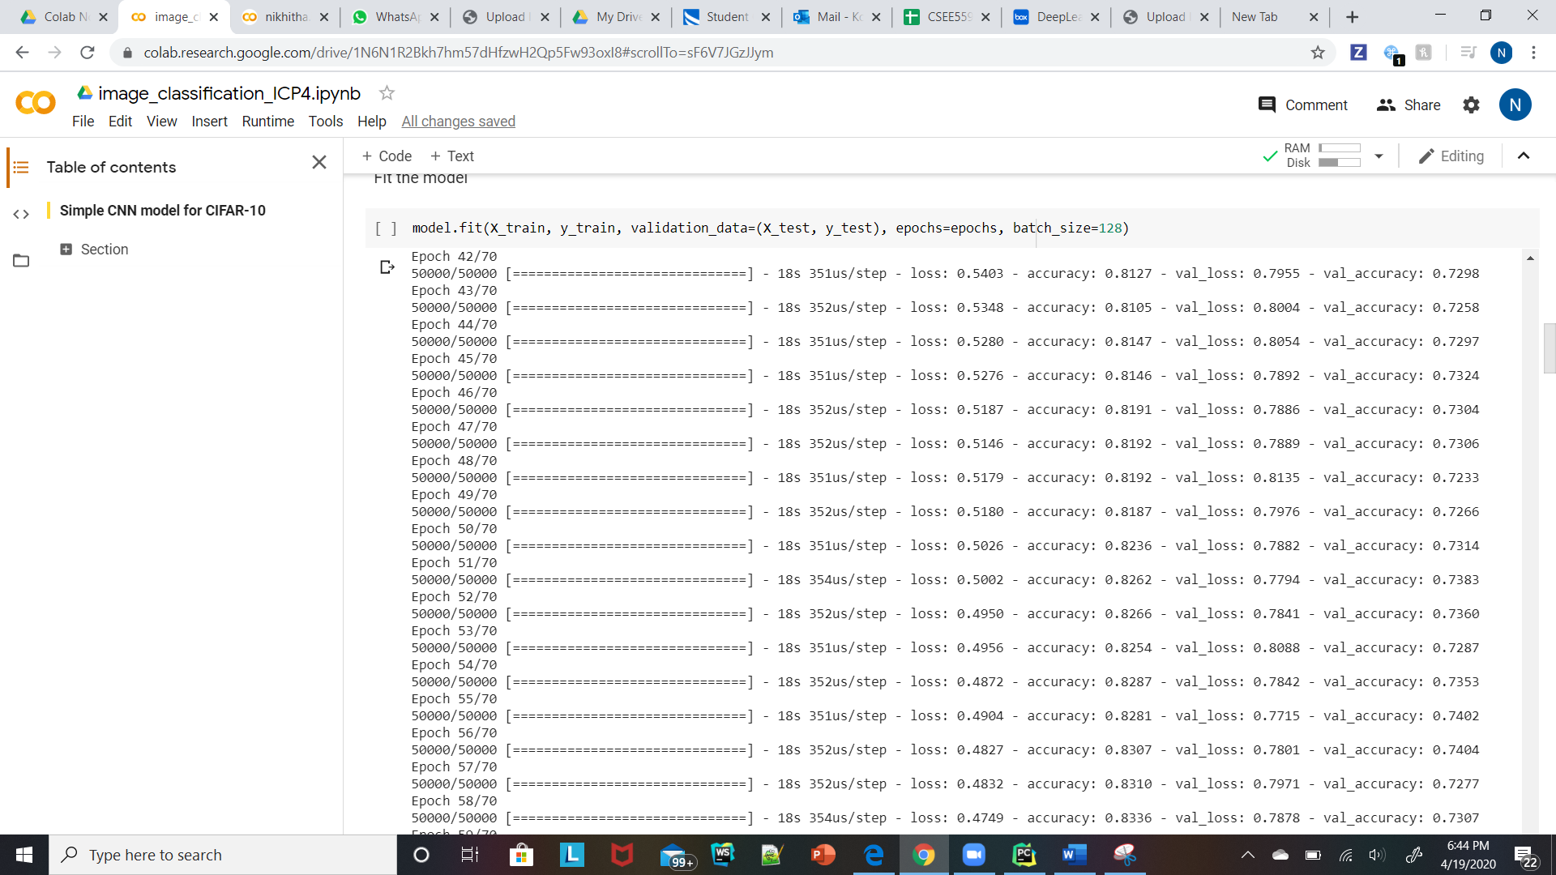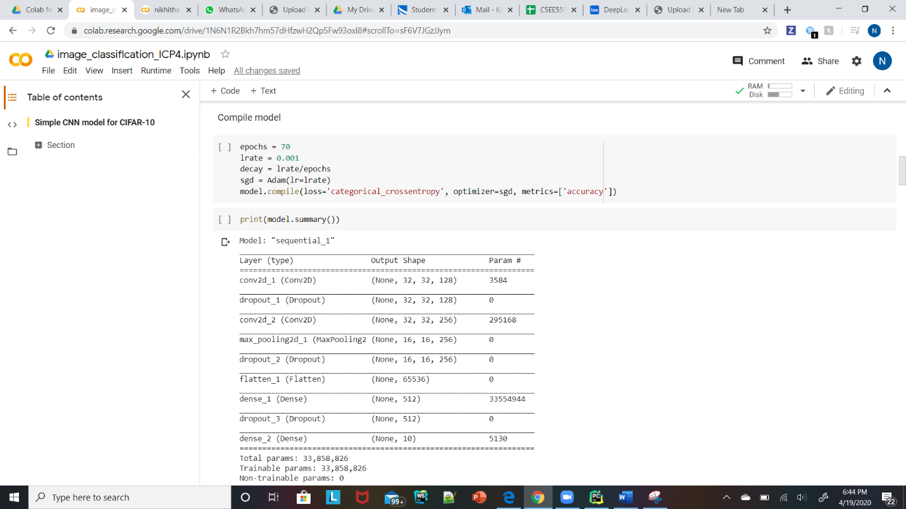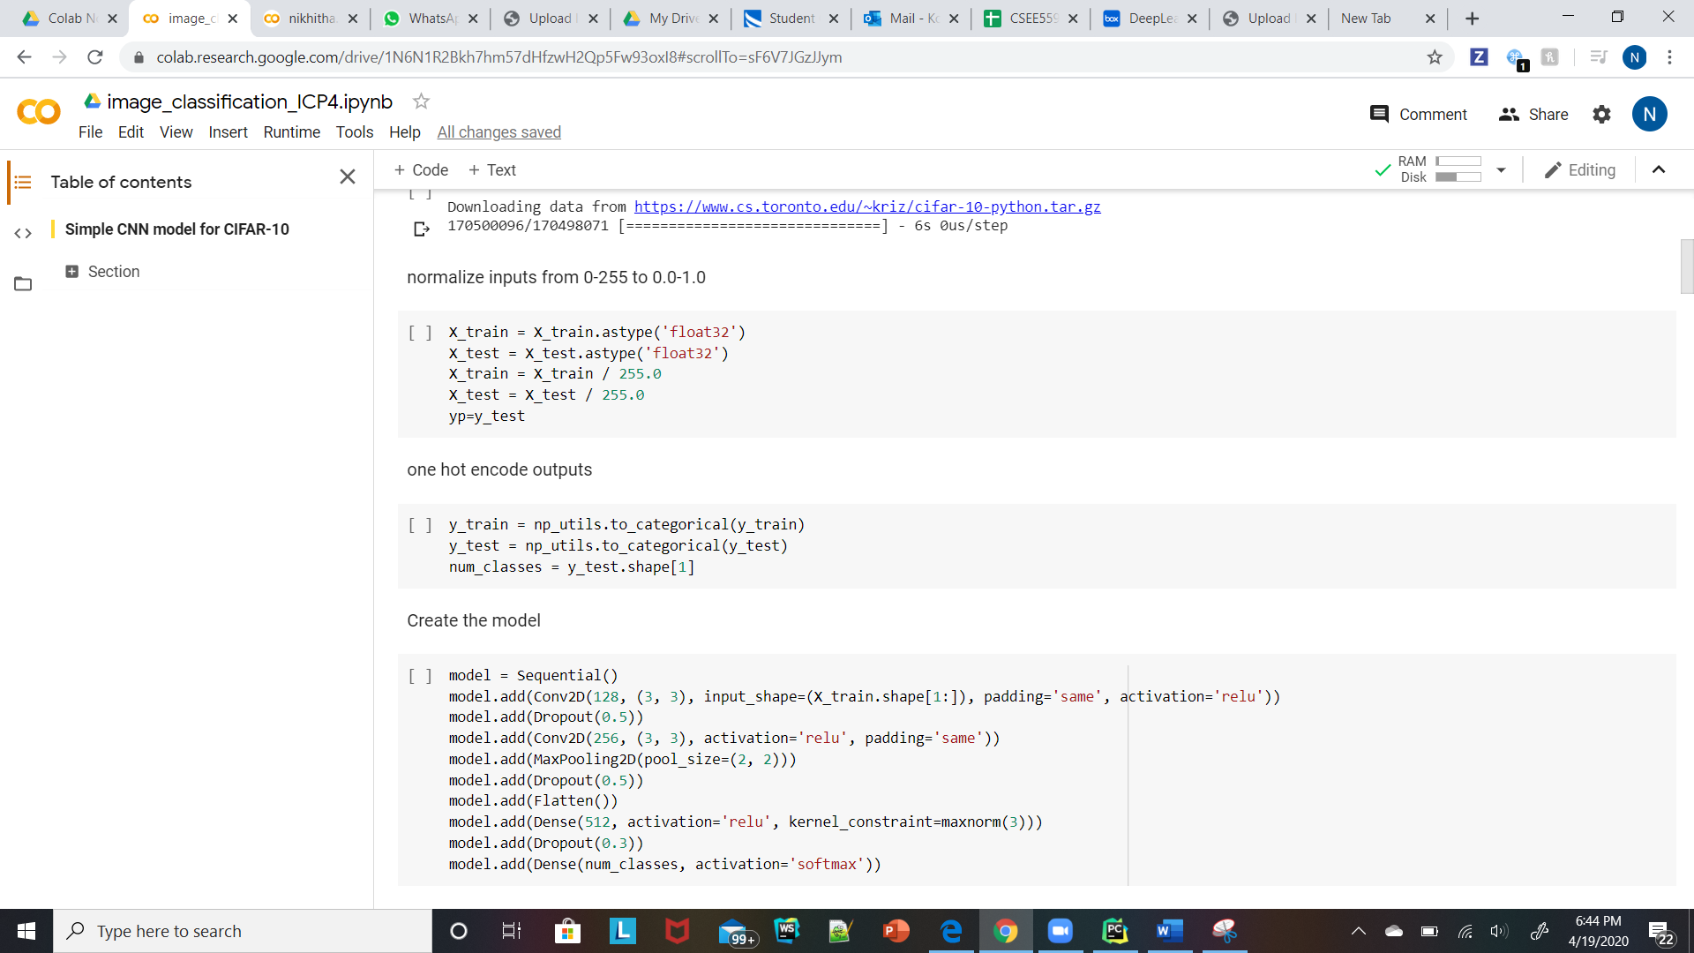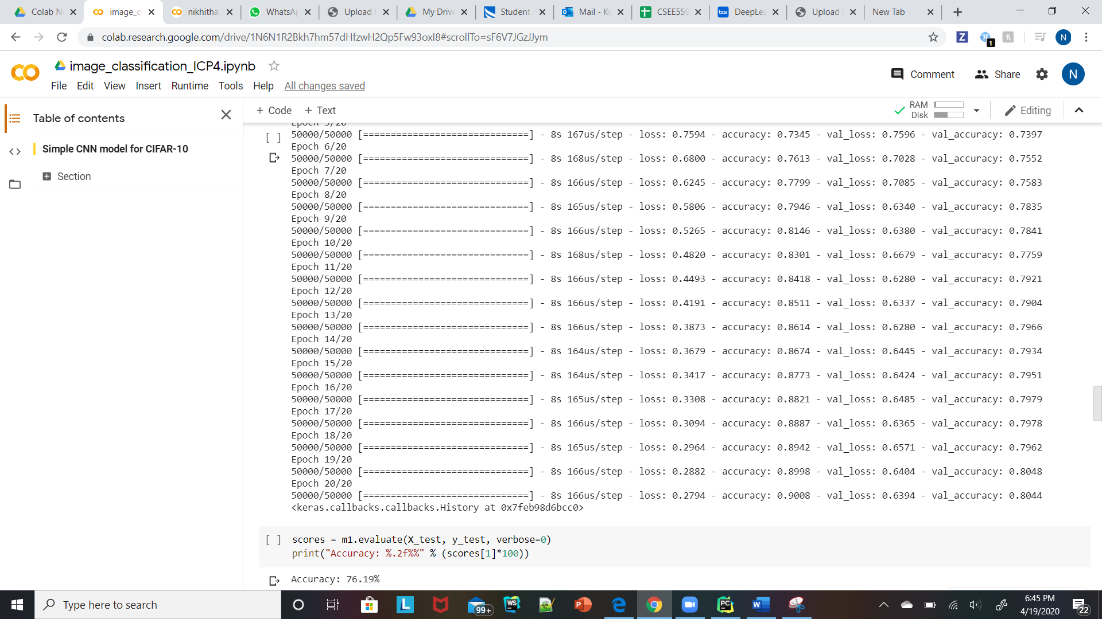

1. Change the previous model into Keras API model.

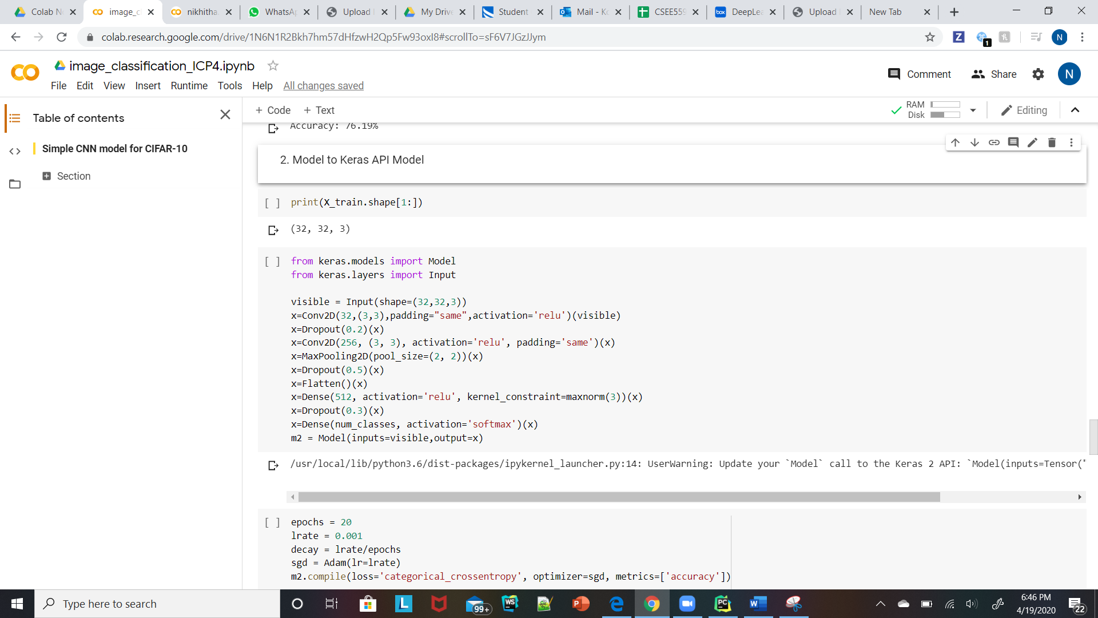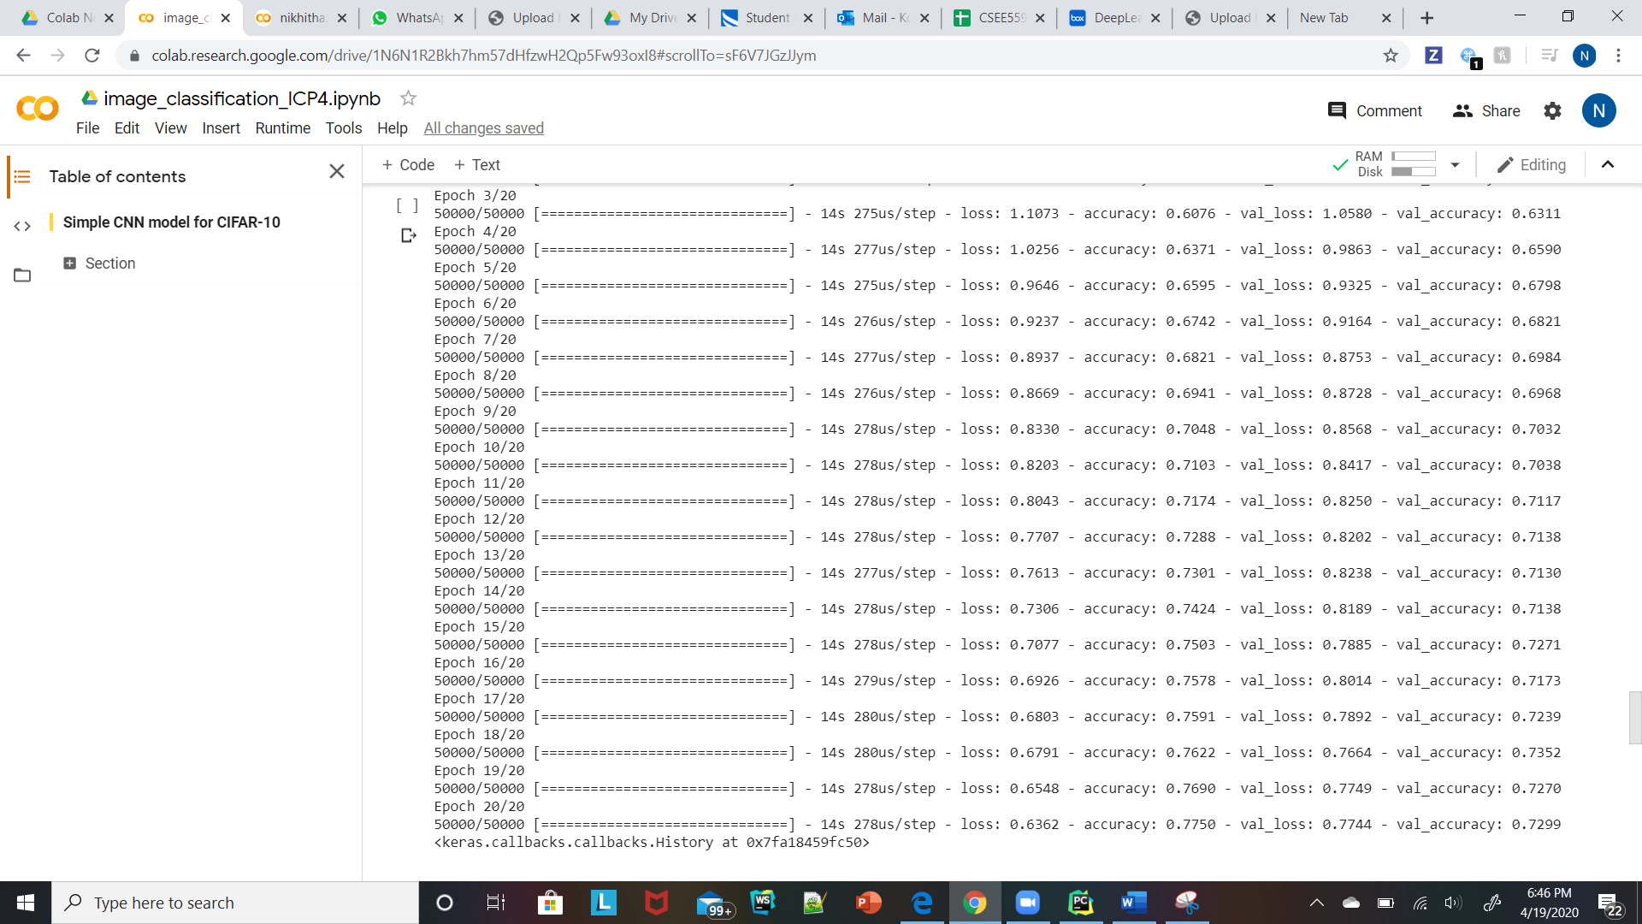

1. predict the first 4 image of the test data. Then, print the actual label for those 4 images (label means the probability associated with them) to check if the model predicted correctly or not

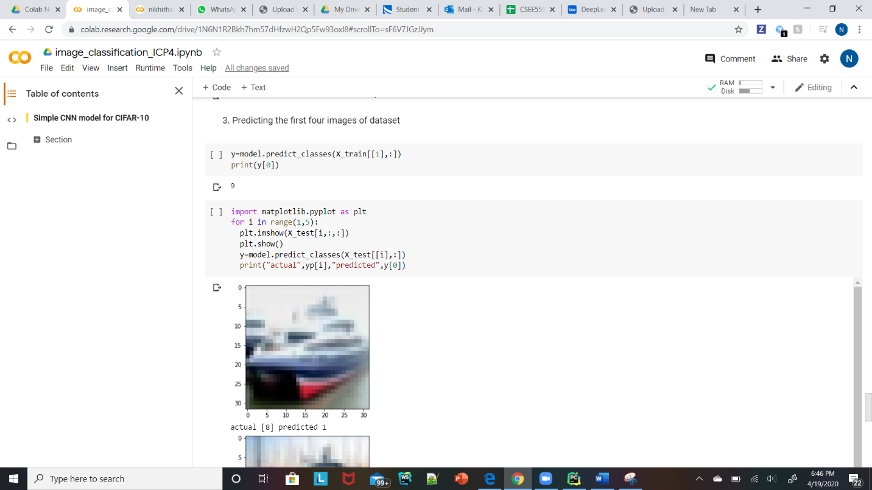

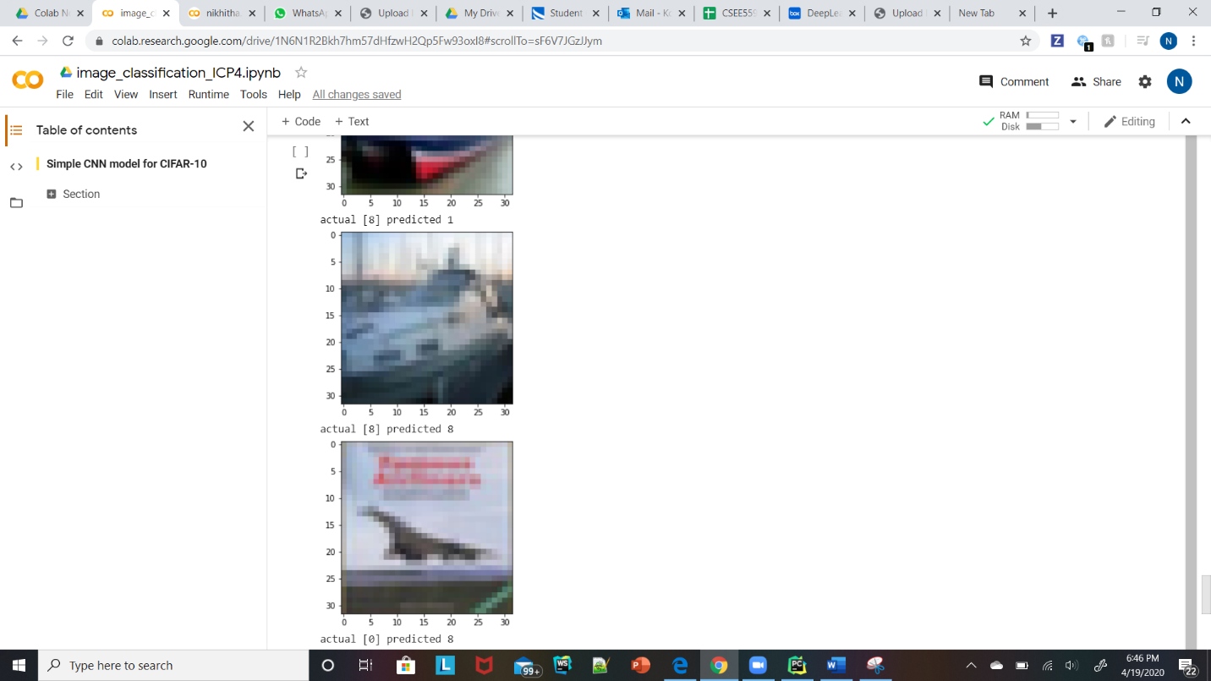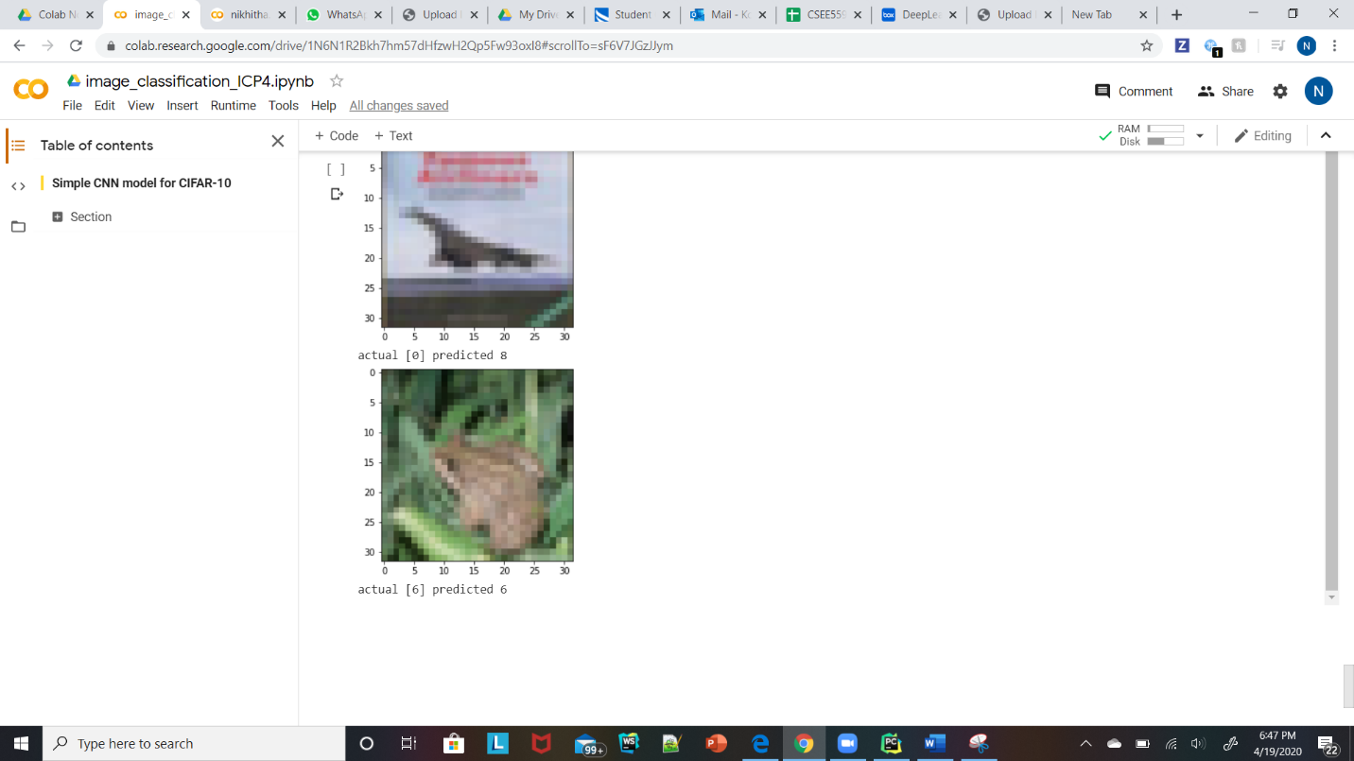

4.Build your own datasetby collecting images from the internetfor example:

-Transportation images (Airplanes, Trains, Cars, ..)

-Animals (Cats, Dogs, ..)

-Creating Client application:

create a webapplication interface for your model using Java script or use Flask library to upload images from your computer and pass them to your model for prediction.

oTrain your model and save your model weights.

oFor predictions load your model weights and do model prediction only.

oShow your model class prediction in your application.

